**CREATE A DATABASE IN CLOUDANT DB**

|  |  |
| --- | --- |
| DATE | 3 NOVEMBER 2022 |
| TEAM ID | **PNT2022TMID14537** |
| PROJECT NAME | GAS LEAKAGE MONITORING AND ALERTING SYSTEM FOR INDUSTRIES |

**Create A Database In Cloudant DB.**

**Aim:** To create a database in Cloudant DB to store location data.

Steps followed:

* Logged in to IBM Cloud account.
* Navigated to `./resources`.
* Clicked on the “Create Resource +” button.
* Searched for “Cloudant”.
* Chose the “Lite Version” and clicked on “Create”.

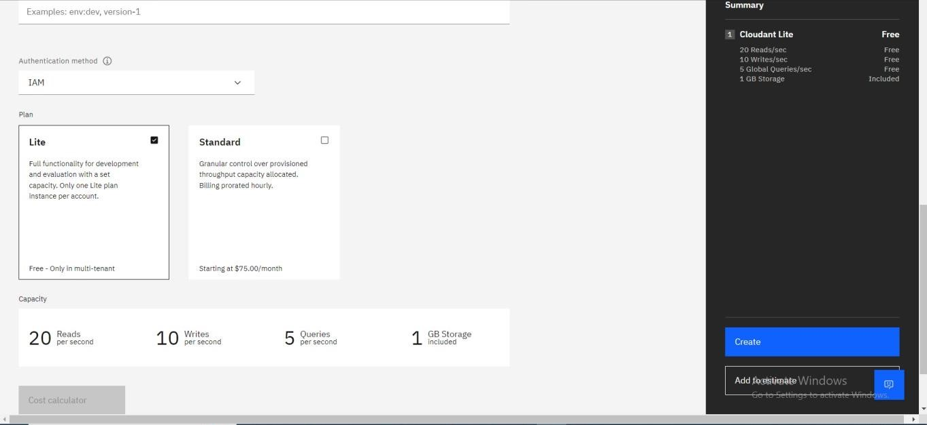

* The Cloudant database resource was created successfully

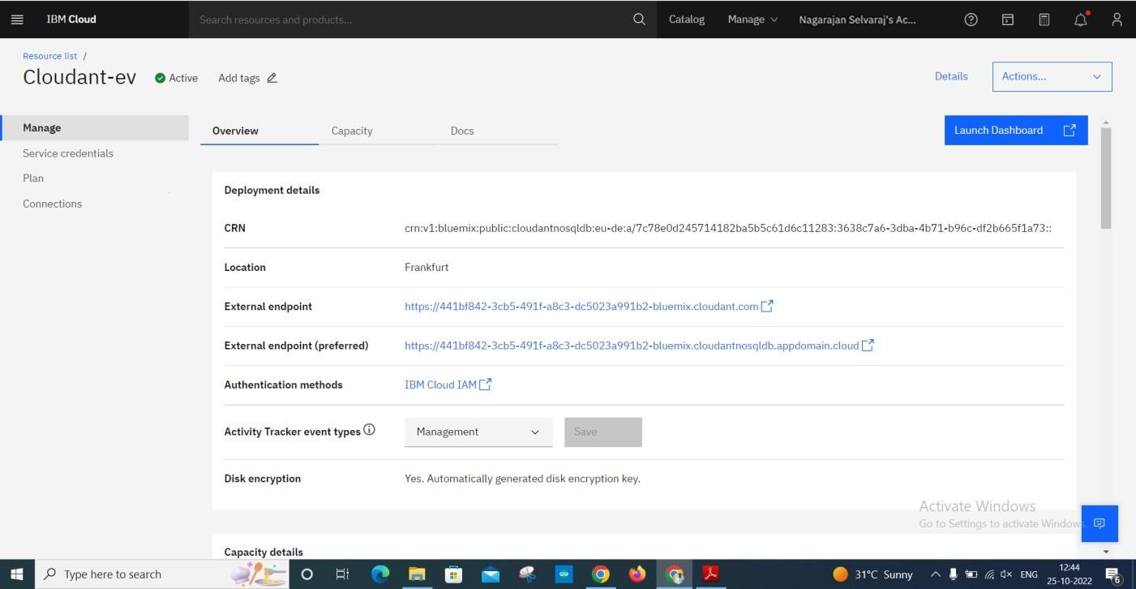

* Clicked on Launch Dashboard

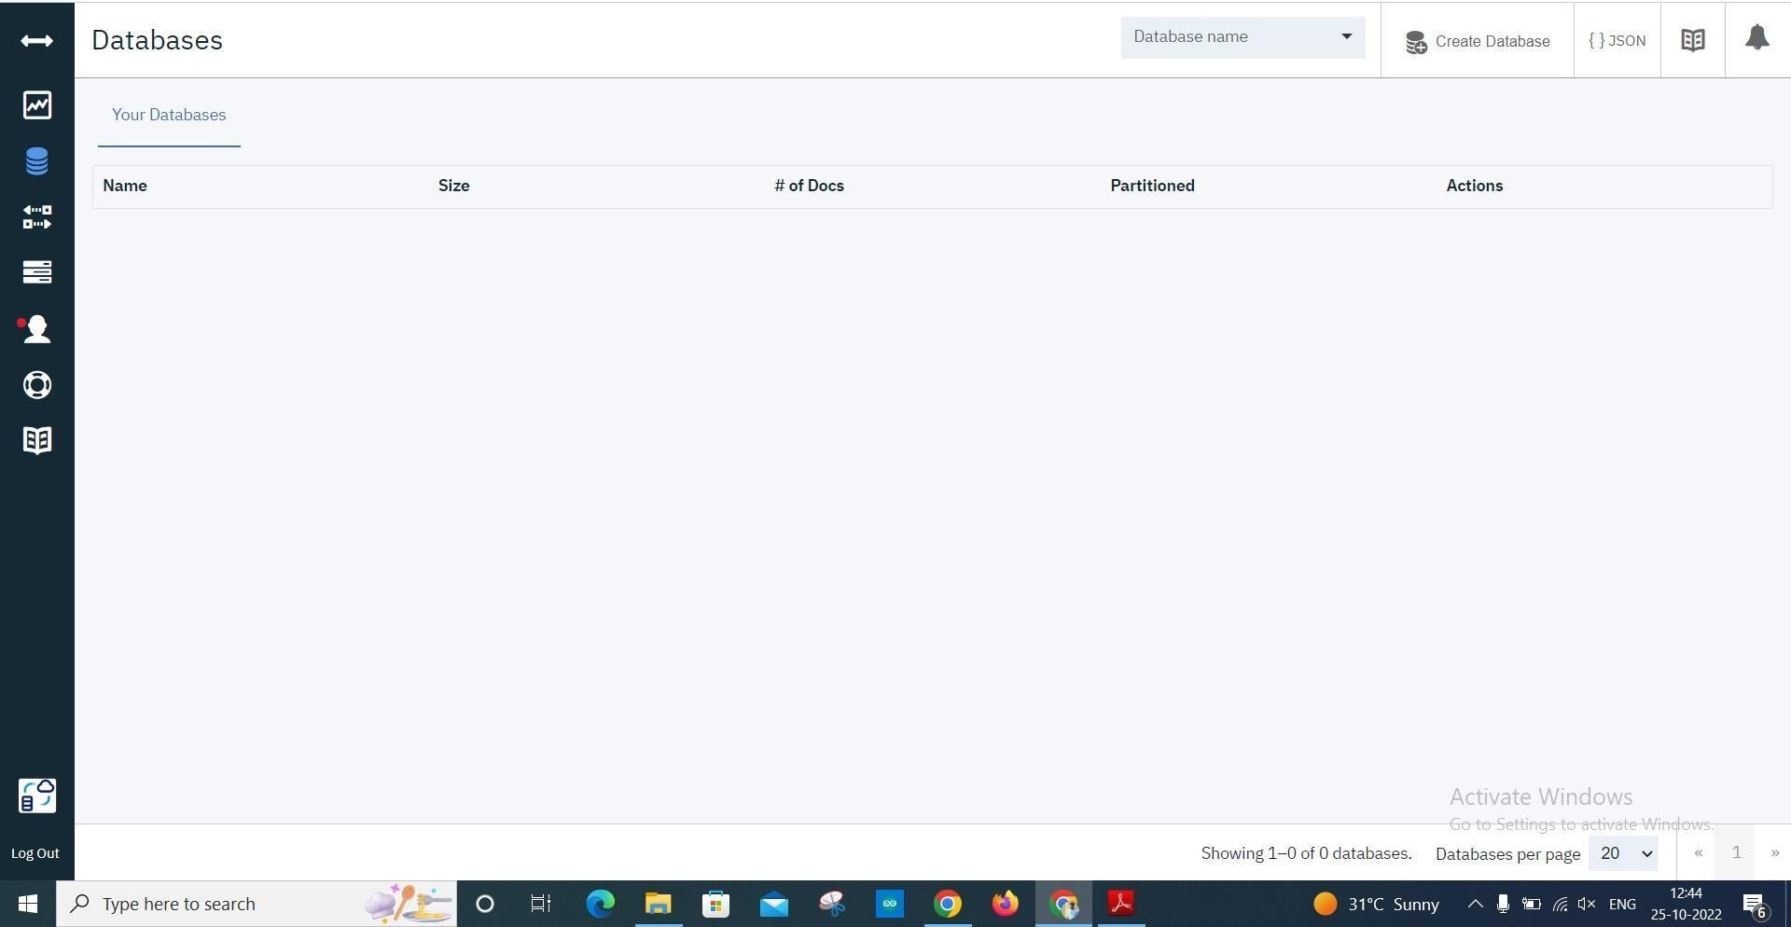

* Clicked on “Create Database”. Enter anything in the database name and the “Nonpartitioned” option.

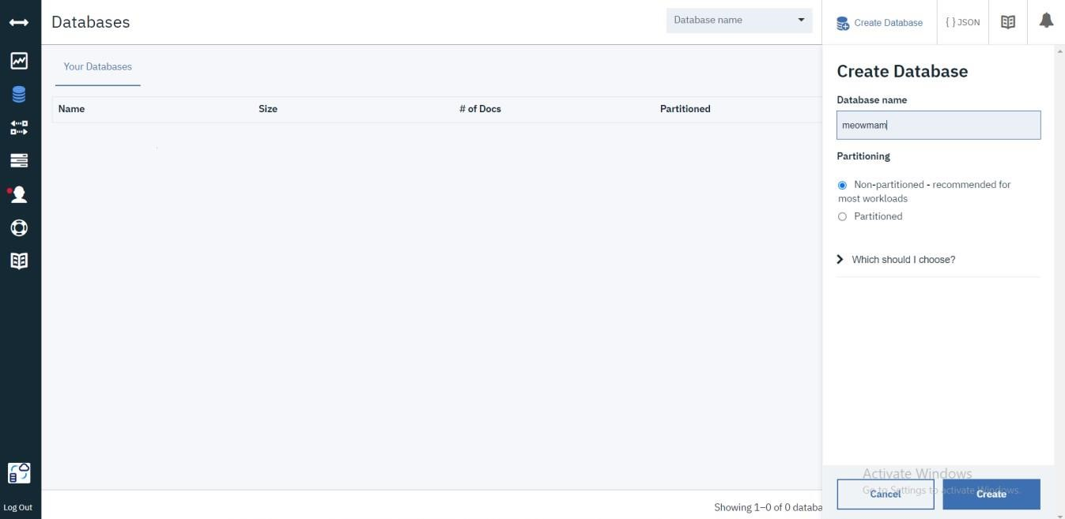

* The database is created successfully.

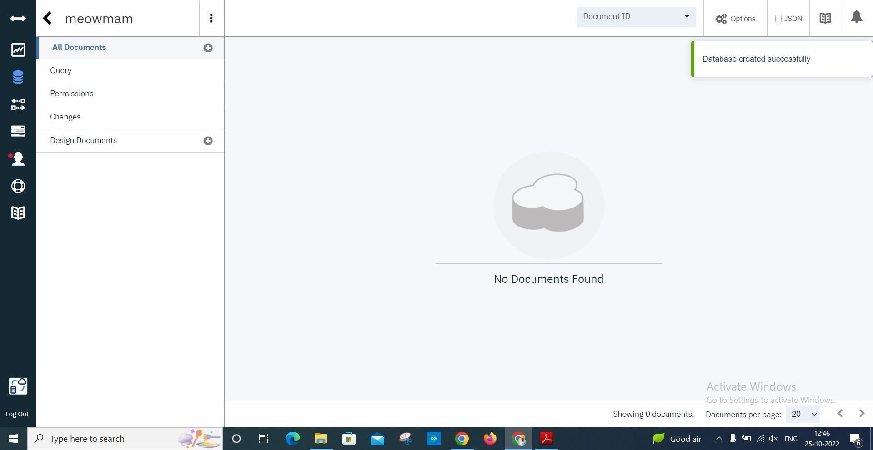

**Result:**

A database to store the location data was created successfully on Cloudant DB.